PARACELSUS MEDICAL UNIVERSITY, SALZBURG, AUSTRIA
ANDREW JENKINSON, ST6 MAXILLOFACIAL SURGERY, WALES

OBJECTIVES
- To observe free tissue transfer employing an intraoral anastomosis technique
- To explore in conversation with the PMU surgeons the patient work-up, perioperative and postoperative care required to safely perform this technique
- Observe some of the less commonly utilised free flaps performed within maxillofacial surgery.

REPORT

I travelled to the Mund-Kiefer-Gesichtschirurgie, Paracelsus Medical University, Salzburg (fig. 1) to learn their intraoral anastomosis technique. In one of my earlier email conversations with the unit I was told that this technique was “routine for them but not their daily business”. Understanding this, I took a chance, planned my visit and hoped I would be lucky enough to observe an intraoral anastomosis. I wasn’t lucky. The day I arrived in the department I was told that one had been performed on the previous day and that there weren’t any scheduled for the remainder of my visit. My disappointment was only short-lived as I was soon in theatre learning another free flap to add to my reconstructive armamentarium, the gracilis flap.
I explored some of the team’s philosophy and approach to microsurgery. Given their success rate of free tissue transfer I thought it was important to take note. Their anastomosis technique was almost identical to mine; ‘back wall first’ with an ‘open loop’ to finish. However, some of their set-up was new to me. One change I will make to my practice is to abandon changing the lie of a pedicle with a suture and instead using a gentle compressive force such as a collagen fibre sheet with fibrin glue. I suspect this technique will reduce the likelihood of creating kinks in the pedicle.

The team is led by Professor Alexander Gaggl. He is a very creative reconstructive surgeon and it was a joy to watch him operate. His implementation of current technology had a great impression on me. One case of osteoradionecrosis of the skull base was safely resected using an on table CT scan, a preoperative PET scan and brain lab to fuse the images to an operating microscope. Although I didn’t see it’s use I was also informed that he uses a robot to undertake supermicrosurgery (fig 2) .

I spent much of my time with Dr Christian Brandtner, one of the senior microsurgeons at the unit. He was generous with his time, helping me understand his tips and pitfalls of intraoral anastomosis. Equally importantly he also encouraged me to explore the beautiful Austrian countryside on my time off (fig 3).

Although I did not see my much-desired intraoral anastomosis technique, I did succeed in learning a lot about reconstructive microsurgery on my short trip. Keith Richards sums up my experiences well “You can’t always get what you want, but if you try sometimes, well, you find you get what you need”. Salzburg is a contemporary maxillofacial unit, led by a reconstructive pioneer. The city is beautiful and the countryside is breath-taking. I would encourage anyone with an interest in contemporary maxillofacial reconstruction to arrange a visit. Thanks to BAOMS for helping make this trip possible with their financial support.

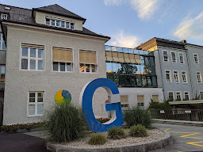
Figure 1. Mund-Kiefer-Gesichtschirurgie, Paracelsus Medical University
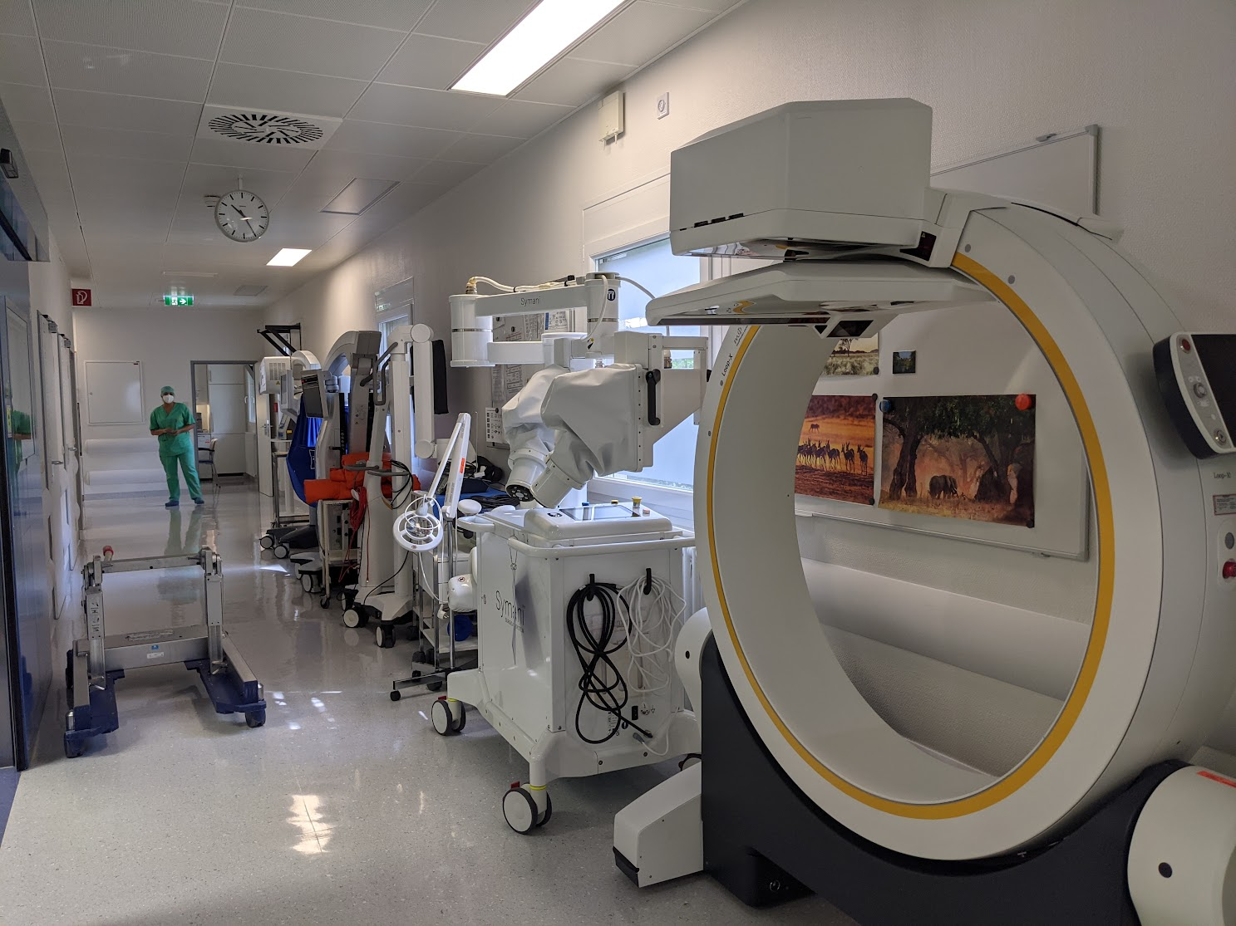
Figure 2. Surgical equipment. Intraoperative CT scanner, Microsurgical robot, brain lab, Operating microscope (right to left)

Figure 3. Lake Konigssee, Berchtesgadener national park

